STRATEGIC PLANNING REPORT
Data-Driven Demand Forecasting, Inventory Control and Route Optimization for a Regional Distribution Network

Week 1 Task: Strategic Planning and Data Exploration in Logistics
Technology focus: Python (pandas, scikit-learn, OR-Tools, matplotlib)
Prepared by: Adarsh Siddharth
Date: 1st October 2026

1. Executive Summary
Logistics costs typically make up a large share of a distributor's operating expenses, and small inefficiencies compound quickly: a forecast that is 10% too low causes stock-outs and lost sales, a forecast that is 10% too high ties up cash in warehouse stock, and a delivery plan built by hand burns fuel on avoidable kilometres. This report sets out the strategy for a Python-based analytics project that tackles all three problems together for a fictional but realistic regional distributor, "RegionalMart Distribution".
The plan covers a clearly defined scenario, six key performance indicators (KPIs), supporting research and public datasets, a mapping between business problems and data science methods (regression, clustering, optimization), and a six-phase roadmap from data collection to deployment. To show feasibility, a working prototype was built and run on synthetic data. In that prototype, a gradient boosting forecaster reduced forecast error (MAPE) from 17.7% for a seasonal-naive baseline to 11.7%, and a savings-heuristic routing model produced delivery plans that were substantially shorter than one-trip-per-store dispatching. The synthetic figures only prove that the pipeline works end to end; real gains must be measured on real data in later weeks.

2. Project Definition

2.1 Logistics scenario
RegionalMart Distribution operates one central distribution centre (DC) that supplies 30 retail stores and kiosks across a metropolitan region with roughly 2,000 stock-keeping units (SKUs) in categories such as packaged food, household goods and personal care. Stores place replenishment orders daily and the DC dispatches a fleet of delivery vans each morning. Today, replenishment quantities are set by planners using last month's sales and experience, and routes are planned manually using a driver's familiarity with each area.
This produces three recurring problems:
- Inventory imbalance: fast-moving SKUs run out during promotions and weekends while slow-moving SKUs pile up in the warehouse.
- Inefficient routing: vans travel overlapping routes, load unevenly, and miss delivery windows, increasing fuel cost and late deliveries.
- Fragmented data: demand, stock and delivery data live in separate spreadsheets and systems, so planners cannot see the whole picture.

2.2 Project objectives
- Predict: Forecast daily SKU-level demand at least 30% more accurately than the current rule-of-thumb baseline.
- Segment and control: Segment SKUs by volume and variability and set safety stock and reorder points per segment instead of one policy for all.
- Optimize: Generate daily delivery routes that respect van capacity and time windows while cutting distance travelled.
- Integrate: Build a KPI dashboard that links forecast, inventory and delivery performance in one view.

2.3 Scope and stakeholders
In scope: demand forecasting, inventory policy, single-depot capacitated route planning, and KPI reporting. Out of scope for this phase: multi-depot network redesign, supplier-side procurement and real-time telematics. Stakeholders include the supply chain planner (forecast and replenishment), the warehouse manager (stock levels), the transport manager (routes and fleet) and the finance head (working capital and logistics cost).

3. Key Performance Indicators
Six KPIs were selected to cover service, inventory, forecasting and transport. The baseline and target values below are planning assumptions typical of regional distributors; they will be replaced with measured values once real data is loaded in Phase 1.
KPI | Definition / formula | Assumed baseline | Target | Why it matters
On-Time In-Full (OTIF) | Orders delivered by promised date with full quantity ÷ total orders | 85% | ≥ 95% | Core customer service measure
Forecast accuracy (MAPE / WMAPE) | Mean of |actual − forecast| ÷ actual × 100 | 25% | ≤ 17% | Drives every replenishment decision
Stock-out rate | SKU-days with zero stock ÷ total SKU-days | 6% | ≤ 2% | Lost sales and store dissatisfaction
Inventory turnover | Cost of goods sold ÷ average inventory value | 8 times / year | 10 times / year | Working capital efficiency
Cost per delivery / km per drop | Total transport cost ÷ deliveries; total km ÷ drops | Baseline from route logs | −10 to −15% | Direct transport cost saving
Vehicle fill rate | Load carried ÷ van capacity | 65% | ≥ 80% | Fleet utilization

These KPIs are linked: better forecast accuracy lowers both stock-outs and excess inventory, which raises OTIF and turnover; better routing raises fill rate and lowers cost per delivery. This linkage is why the project treats forecasting, inventory and routing as one system rather than three isolated tasks.

4. Background Research and Data Sources

4.1 Literature and methods
The approach builds on well-established work in operations research and forecasting:
- Routing: Dantzig and Ramser (1959) introduced the Vehicle Routing Problem, and Clarke and Wright (1964) proposed the savings algorithm, which remains a standard fast heuristic. Toth and Vigo (2014) review modern exact and heuristic methods.
- Forecasting: Hyndman and Athanasopoulos (Forecasting: Principles and Practice) describe baseline benchmarks, time-series cross-validation and accuracy metrics. The M5 forecasting competition (Makridakis et al., 2022), based on Walmart sales data, showed that gradient boosted trees with lag and calendar features are highly competitive for retail demand.
- Inventory: Silver, Pyke and Thomas (Inventory and Production Management in Supply Chains) and Chopra and Meindl (Supply Chain Management) give the safety stock, reorder point and service-level formulas used here.
- Segmentation: ABC/XYZ analysis classifies items by value and demand variability. K-Means clustering extends this idea by letting the data define the segments.
- Practice: MIT's Amazon Last Mile Routing Research Challenge (Winkenbach et al., 2021) showed that real driver behaviour contains knowledge that pure shortest-distance models miss, which is a useful caution when comparing optimized and human routes.

4.2 Public datasets identified
The following public resources can support the scenario. Licenses and current availability should be confirmed on each source before use.
Dataset | Content | Use in this project
M5 Forecasting (Kaggle / University of Nicosia) | Daily unit sales for about 3,000 products across 10 Walmart stores, with prices and calendar events | Train and benchmark the demand forecasting model
DataCo Smart Supply Chain (Kaggle / Mendeley Data) | Orders, shipping mode, delivery status, late-delivery risk, regions | OTIF and late-delivery analysis, delay prediction
Olist Brazilian E-Commerce (Kaggle) | About 100,000 orders with customer and seller locations, freight value, delivery dates | Delivery time analysis, geographic clustering, freight cost
Amazon Last Mile Routing Challenge (MIT CTL, open data) | Real delivery routes, stops and package data | Benchmark route optimization against real driver routes
CVRPLIB / Solomon benchmark instances | Standard vehicle routing problem instances with known best solutions | Validate routing code against known optimal results
World Bank Logistics Performance Index | Country-level logistics performance scores | Context and benchmarking for the business case

4.3 Applying data science concepts
Logistics challenge | Technique | Python tools | KPI improved
Predict SKU demand | Regression (linear baseline, gradient boosting) on lag, rolling and calendar features | pandas, scikit-learn, statsmodels | Forecast accuracy, stock-out rate
Group items and stores with similar behaviour | Clustering (K-Means) on volume, variability, location | scikit-learn, seaborn | Inventory turnover, stock-out rate
Set stock levels | Statistical inventory models (safety stock, reorder point) | numpy, scipy | Turnover, OTIF
Plan delivery routes | Optimization: capacitated VRP with time windows (savings heuristic, metaheuristics) | OR-Tools, networkx | Cost per delivery, fill rate
Predict late deliveries | Classification (logistic regression, random forest) | scikit-learn | OTIF
Detect data errors and unusual orders | Outlier and anomaly detection (IQR, isolation forest) | scikit-learn | Data quality, accuracy

5. Strategic Roadmap
The end-to-end process follows six phases. Each phase has a clear output so that progress can be checked before moving on.
Phase | Timing | Key activities | Deliverable
1. Data collection | Weeks 1-2 | Identify sources (orders, stock, routes); load public datasets; define data dictionary and KPI formulas | Raw data in data/raw, data dictionary
2. Data cleaning | Weeks 2-3 | Remove duplicates, fix types, impute missing values, treat outliers, join tables on SKU, store and date | Clean analytical table in data/processed
3. Exploratory analysis | Weeks 3-4 | Trend, seasonality, promotion effects, demand variability, delivery delay patterns, correlation checks | EDA notebook with charts and findings
4. Modeling | Weeks 4-7 | Feature engineering; forecasting with benchmark and ML models; SKU clustering; inventory policy; routing optimization | Trained models and evaluation report
5. Evaluation | Weeks 7-8 | Time-based validation; compare against baselines; simulate inventory and routing savings; sensitivity checks | KPI before/after comparison
6. Reporting and deployment | Weeks 8-10 | Dashboard, documentation, scheduled daily run, handover to planners | Dashboard, runbook, final report

Process flow: Data sources → Ingestion and validation → Cleaning and integration → Exploratory analysis → Feature engineering → Forecasting model → Inventory policy (safety stock, reorder point) → Route optimization → KPI dashboard → Decision and feedback → back to data sources.
The feedback loop is important: actual sales and delivery results from each day are written back to the data store so the models can be retrained on a fixed schedule (for example weekly) and monitored for drift.

6. Code Illustration
The following scripts illustrate each stage of the plan. The full runnable prototype (src/logistics_pipeline.py) generates synthetic data so the pipeline can be tested before real data is available. File paths in the first snippet are placeholders for the real extracts.

6.1 Data collection, cleaning and an OTIF KPI
import pandas as pd, numpy as np

# 1. Collect: load raw operational extracts (real data or public datasets)
orders = pd.read_csv("data/raw/orders.csv", parse_dates=["order_date", "promised_date", "delivered_date"])
inventory = pd.read_csv("data/raw/inventory_snapshots.csv", parse_dates=["date"])
deliveries = pd.read_csv("data/raw/delivery_routes.csv")

# 2. Clean: duplicates, types, missing values, outliers
orders = orders.drop_duplicates("order_id")
orders["qty"] = pd.to_numeric(orders["qty"], errors="coerce")
orders["qty"] = orders.groupby("sku")["qty"].transform(lambda s: s.interpolate(limit_direction="both"))

q1, q3 = orders["qty"].quantile([.25, .75])
orders["qty"] = orders["qty"].clip(upper=q3 + 3 * (q3 - q1)) # winsorise spikes

# 3. KPI: On-Time-In-Full (OTIF)
orders["on_time"] = orders["delivered_date"] <= orders["promised_date"]
orders["in_full"] = orders["qty_delivered"] >= orders["qty"]
otif = (orders["on_time"] & orders["in_full"]).mean() * 100
print(f"OTIF = {otif:.1f}%")

6.2 Feature engineering and exploratory analysis
def add_features(df):
g = df.groupby("sku")["units"]
df["lag_1"], df["lag_7"], df["lag_28"] = g.shift(1), g.shift(7), g.shift(28)
df["roll_mean_7"] = g.shift(1).rolling(7).mean().reset_index(level=0, drop=True)
df["roll_mean_28"] = g.shift(1).rolling(28).mean().reset_index(level=0, drop=True)
df["dow"], df["month"] = df["date"].dt.dayofweek, df["date"].dt.month
return df.dropna()

# Quick EDA: weekly seasonality and demand variability per SKU
df.groupby("dow")["units"].mean().plot(kind="bar", title="Average demand by weekday")
cv = df.groupby("sku")["units"].agg(lambda s: s.std() / s.mean()) # coefficient of variation

6.3 Predictive modeling: demand forecast
A time-based train/test split is used instead of a random split, because random splits leak future information into training and give overly optimistic results for time series.
from sklearn.ensemble import GradientBoostingRegressor
from sklearn.metrics import mean_absolute_error

FEATS = ["lag_1", "lag_7", "lag_28", "roll_mean_7", "roll_mean_28",
"dow", "month", "promo", "sku_code"]
cutoff = df["date"].max() - pd.Timedelta(days=60) # time-based split (no leakage)
train, test = df[df.date <= cutoff], df[df.date > cutoff]

model = GradientBoostingRegressor(n_estimators=250, max_depth=4, learning_rate=0.05, random_state=42)
model.fit(train[FEATS], train["units"])
pred = model.predict(test[FEATS])

mape = (abs(test.units - pred) / test.units.clip(lower=1)).mean() * 100
naive = test["lag_7"] # seasonal-naive benchmark
print("Model MAE:", mean_absolute_error(test.units, pred))
print("Baseline MAE:", mean_absolute_error(test.units, naive))

6.4 Clustering and inventory policy
from sklearn.cluster import KMeans
from sklearn.preprocessing import StandardScaler

s = df.groupby("sku")["units"].agg(["mean", "std"])
s["cv"], s["volume"] = s["std"] / s["mean"], s["mean"] * 365
X = StandardScaler().fit_transform(np.column_stack([np.log1p(s["volume"]), s["cv"]]))
s["cluster"] = KMeans(n_clusters=3, n_init=10, random_state=42).fit_predict(X)

# Inventory policy per SKU: safety stock and reorder point (service level 95%, z = 1.65)
lead_time = 3
s["safety_stock"] = 1.65 * s["std"] * np.sqrt(lead_time)
s["reorder_point"] = s["mean"] * lead_time + s["safety_stock"]

6.5 Route optimization
Two routing options are shown. The first uses Google OR-Tools, which is the preferred production tool because it handles capacity and time window constraints. The second is a pure Python Clarke-Wright savings heuristic, used in the prototype because it needs no extra installation. The OR-Tools snippet is illustrative and was not executed in the prototype environment.
Option A: OR-Tools capacitated VRP (illustrative)
# Capacitated Vehicle Routing with Google OR-Tools (illustrative; pip install ortools)
from ortools.constraint_solver import pywrapcp, routing_enums_pb2

def solve_cvrp(dist_matrix, demands, vehicle_capacity, n_vehicles, depot=0):
manager = pywrapcp.RoutingIndexManager(len(dist_matrix), n_vehicles, depot)
routing = pywrapcp.RoutingModel(manager)

def cost(i, j): return int(dist_matrix[manager.IndexToNode(i)][manager.IndexToNode(j)])
def demand(i): return demands[manager.IndexToNode(i)]
routing.SetArcCostEvaluatorOfAllVehicles(routing.RegisterTransitCallback(cost))
routing.AddDimensionWithVehicleCapacity(routing.RegisterUnaryTransitCallback(demand), 0,
[vehicle_capacity] * n_vehicles, True, "Capacity")

params = pywrapcp.DefaultRoutingSearchParameters()
params.first_solution_strategy = routing_enums_pb2.FirstSolutionStrategy.PATH_CHEAPEST_ARC
params.local_search_metaheuristic = routing_enums_pb2.LocalSearchMetaheuristic.GUIDED_LOCAL_SEARCH
params.time_limit.seconds = 30
return routing.SolveWithParameters(params)

Option B: Clarke-Wright savings heuristic (executed in prototype)
def savings_vrp(depot, stops, demand, capacity):
"""Clarke-Wright savings heuristic: merge routes with the largest distance savings first."""
n = len(stops)
routes, load, where = {i: [i] for i in range(n)}, dict(enumerate(demand)), {i: i for i in range(n)}
savings = sorted(((dist(depot, stops[i]) + dist(depot, stops[j]) - dist(stops[i], stops[j]), i, j)
for i in range(n) for j in range(i + 1, n)), reverse=True)
for _, i, j in savings:
ri, rj = where[i], where[j]
if ri == rj or load[ri] + load[rj] > capacity:
continue
a, b = routes[ri], routes[rj]
if a[-1] == i and b[0] == j: merged = a + b
elif a[0] == i and b[-1] == j: merged = b + a
elif a[0] == i and b[0] == j: merged = a[::-1] + b
elif a[-1] == i and b[-1] == j: merged = a + b[::-1]
else: continue
routes[ri], load[ri] = merged, load[ri] + load[rj]
del routes[rj], load[rj]
for k in merged: where[k] = ri
return list(routes.values())

6.6 Prototype results on synthetic data
The prototype was run on 40 synthetic SKUs over 730 days, with 100 deliberately missing values and 100 inflated outliers injected to test cleaning. All missing values were removed by the cleaning step. Results on the final 60 days held out for testing:
Model | MAE (units) | MAPE | Result
Seasonal naive (same weekday last week) | 12.45 | 17.7% | Baseline
Gradient boosting with lag features | 7.68 | 11.7% | Better on both metrics

K-Means split the 40 SKUs into three groups (18, 8 and 14 SKUs) with different volume and variability profiles, which supports using a separate stock policy per group. For routing, the savings heuristic served 30 stores with 5 vans (capacity 100 units each) and cut total distance from about 2,076 to 686 distance units compared with one dedicated round trip per store. That baseline is deliberately simple, so the 67% saving overstates what will be achieved against real manual routes; a realistic target is the 10-15% cost reduction listed in Section 3.
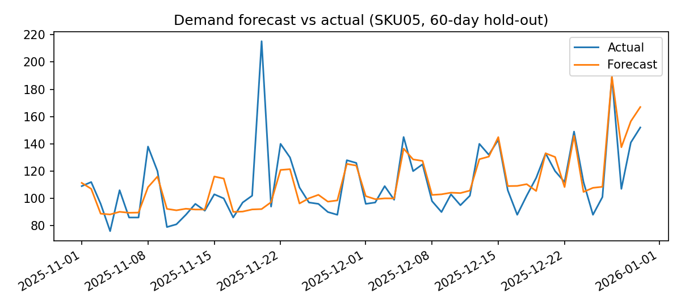
Figure 1: Forecast vs actual demand on the hold-out period (synthetic data)
Because the synthetic data was generated with weekly and yearly patterns, the model's success here is expected. It confirms the code and evaluation logic work, not that the same accuracy will occur on real demand.
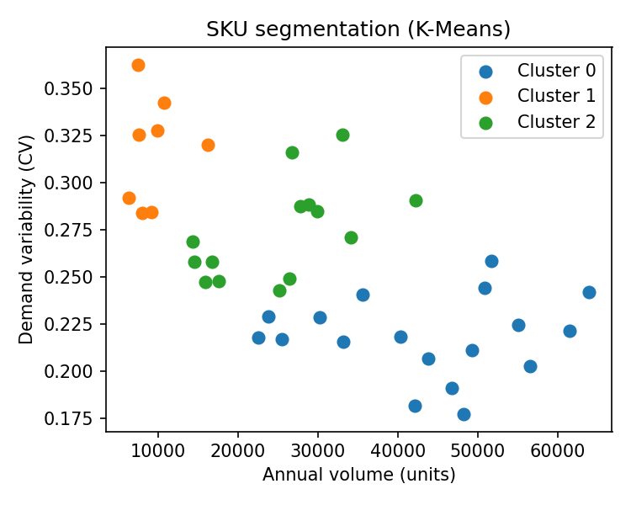
Figure 2: SKU segmentation by annual volume and demand variability
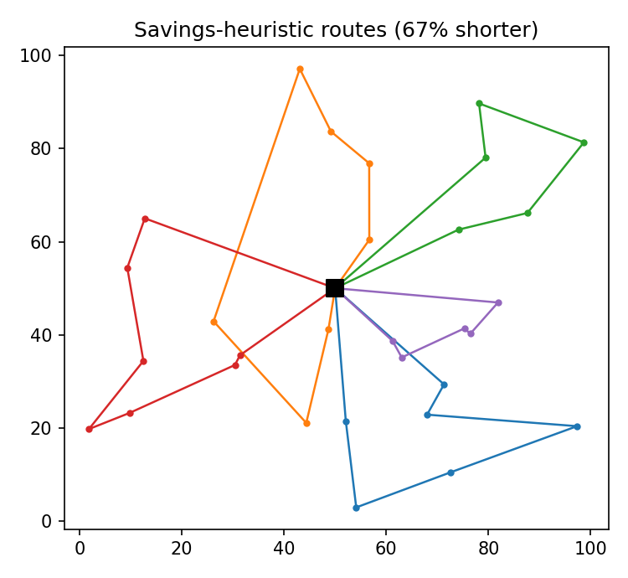
Figure 3: Routes from the savings heuristic (square = depot)

7. Risks and Mitigation
Risk | Impact | Mitigation
Poor or missing data quality | Biased forecasts and wrong KPIs | Validation rules, data dictionary, documented imputation choices
Overfitting / data leakage | Accuracy looks good in testing but fails in practice | Time-based splits, rolling-origin validation, baseline comparison
Intermittent demand for slow SKUs | Gradient boosting may underperform | Use Croston-type methods or aggregate to weekly level for these items
Planner resistance to model output | Recommendations ignored | Show explanations (feature importance), allow manual override, pilot with one region
Public data differs from real operations | Results do not transfer | Treat public data as a testbed; retrain and revalidate on company data
Real-world routing constraints (traffic, driver preferences) | Optimized routes are not followed | Add time windows and driver input; compare against actual routes

8. Expected Outcomes and Impact on Decision-Making
If the roadmap is carried out, the project is expected to deliver the following, each of which will be verified against the baselines recorded in Phase 1:
- Better forecasts: a forecast model with materially lower error than the current rule-of-thumb method, reported by SKU group.
- Smarter inventory: stock policies tailored to each SKU segment, aiming to lower stock-outs toward 2% while raising inventory turnover.
- Efficient transport: daily route plans that raise vehicle fill rate and reduce kilometres and cost per delivery by an estimated 10-15%.
- Shared visibility: one dashboard linking forecast accuracy, stock levels and delivery performance.
The main effect on decision-making is a shift from reactive to proactive planning. Planners would see projected demand and stock-out risk several days ahead, so they can adjust orders before shortages occur. Transport managers would start each day with a feasible optimized plan that they can review and adjust rather than building routes from scratch. Finance gets a measurable link between logistics decisions and working capital. Because each recommendation is backed by a tracked KPI, management can judge whether the analytics are paying off and decide where to extend them, for example to multi-depot planning.

9. Conclusion
This report defined a realistic distribution scenario, selected six interlinked KPIs, grounded the approach in established forecasting, inventory and routing research, and identified public datasets that allow the work to start without confidential company data. The six-phase roadmap moves logically from data collection through cleaning, exploration, modeling and evaluation to deployment, and the working prototype shows that each technical step is feasible in Python with widely used open-source libraries.
The next steps are to load a public dataset such as M5 or DataCo, replace the synthetic data in the prototype, record true baseline KPI values, and begin the exploratory analysis phase. Success will be judged by measured improvement over those baselines, not by results on synthetic data.

10. References
- Chopra, S. and Meindl, P. Supply Chain Management: Strategy, Planning and Operation. Pearson.
- Clarke, G. and Wright, J. W. (1964). Scheduling of vehicles from a central depot to a number of delivery points. Operations Research, 12(4), 568-581.
- Dantzig, G. B. and Ramser, J. H. (1959). The truck dispatching problem. Management Science, 6(1), 80-91.
- Hyndman, R. J. and Athanasopoulos, G. Forecasting: Principles and Practice. OTexts (free online at otexts.com/fpp3).
- Makridakis, S., Spiliotis, E. and Assimakopoulos, V. (2022). M5 accuracy competition: Results, findings and conclusions. International Journal of Forecasting, 38(4), 1346-1364.
- Silver, E. A., Pyke, D. F. and Thomas, D. J. Inventory and Production Management in Supply Chains. CRC Press.
- Toth, P. and Vigo, D. (2014). Vehicle Routing: Problems, Methods, and Applications (2nd ed.). SIAM.
- Winkenbach, M. et al. (2021). Amazon Last Mile Routing Research Challenge. MIT Center for Transportation and Logistics.
- Google OR-Tools documentation: developers.google.com/optimization
- Kaggle: M5 Forecasting - Accuracy; DataCo Smart Supply Chain for Big Data Analysis; Brazilian E-Commerce Public Dataset by Olist.
- World Bank. Logistics Performance Index: lpi.worldbank.org

Appendix: Proposed GitHub Repository Structure
logistics-analytics-plan/
├── README.md
├── requirements.txt
├── data/
│ ├── raw/ # untouched source files (not committed if large)
│ └── processed/ # cleaned analytical tables
├── notebooks/
│ ├── 01_eda.ipynb
│ └── 02_modeling.ipynb
├── src/
│ └── logistics_pipeline.py # end-to-end prototype
├── figures/
└── reports/
└── Week1_Strategic_Planning_Report.docx

